1.Write a program to print all the composite numbers between a and b?

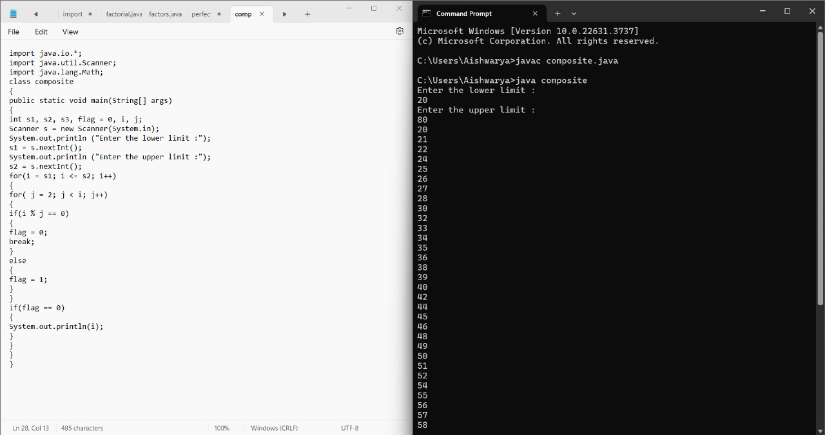

2. Find the factorial of n using while loop

Sample Input:

N = 4

Sample Output:

4 Factorial = 24

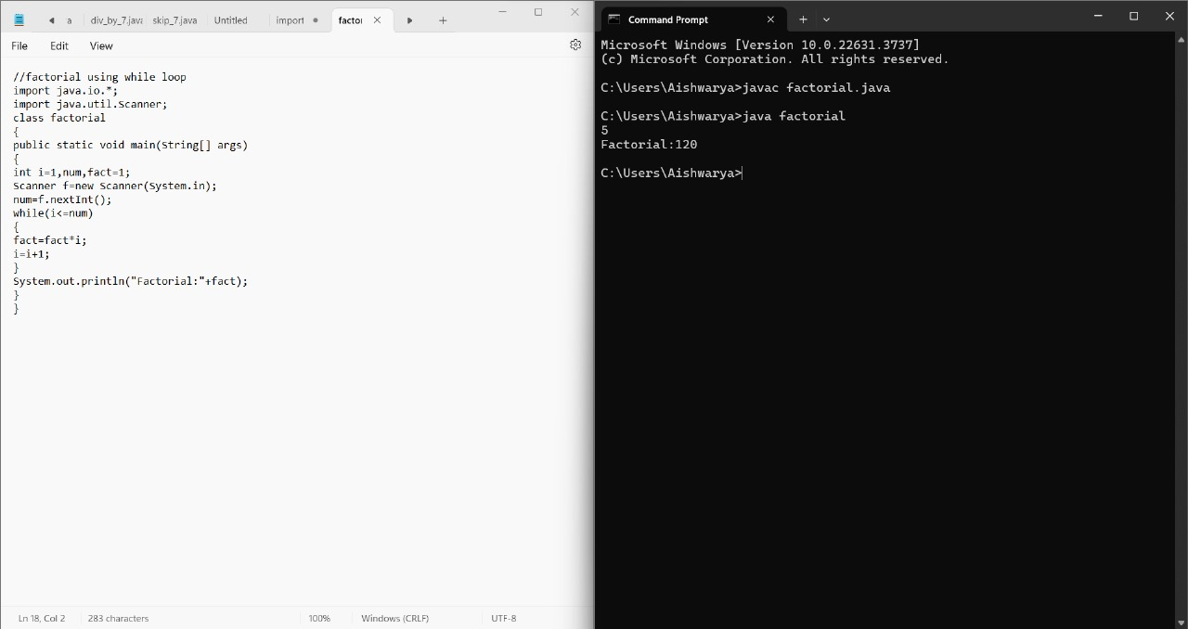

3. Find the number of factors for the given number

Sample Input:

Given number: 100

Sample Output:

Number of factors = 9

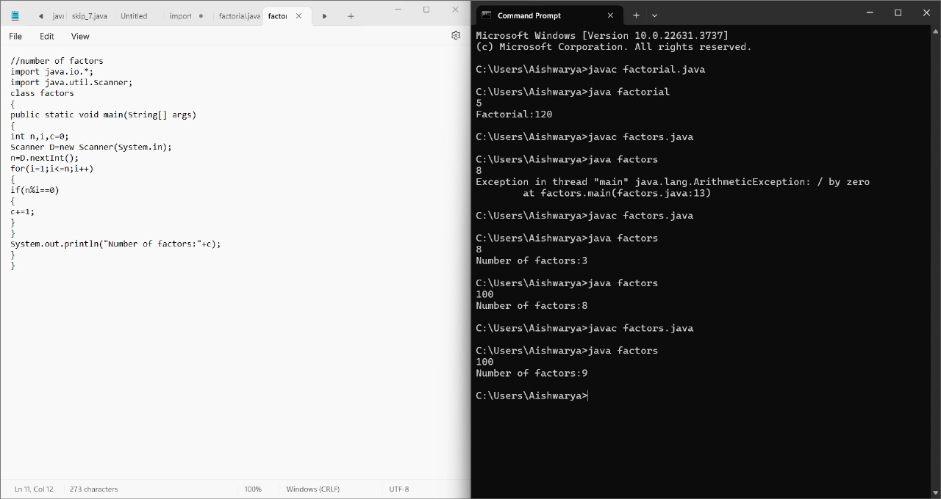

4. Write a program to find the square root of a perfect square number(print both the positive and negative values)

Sample Input:

Enter the number : 6561

Sample Output:

Square Root: 81, -81

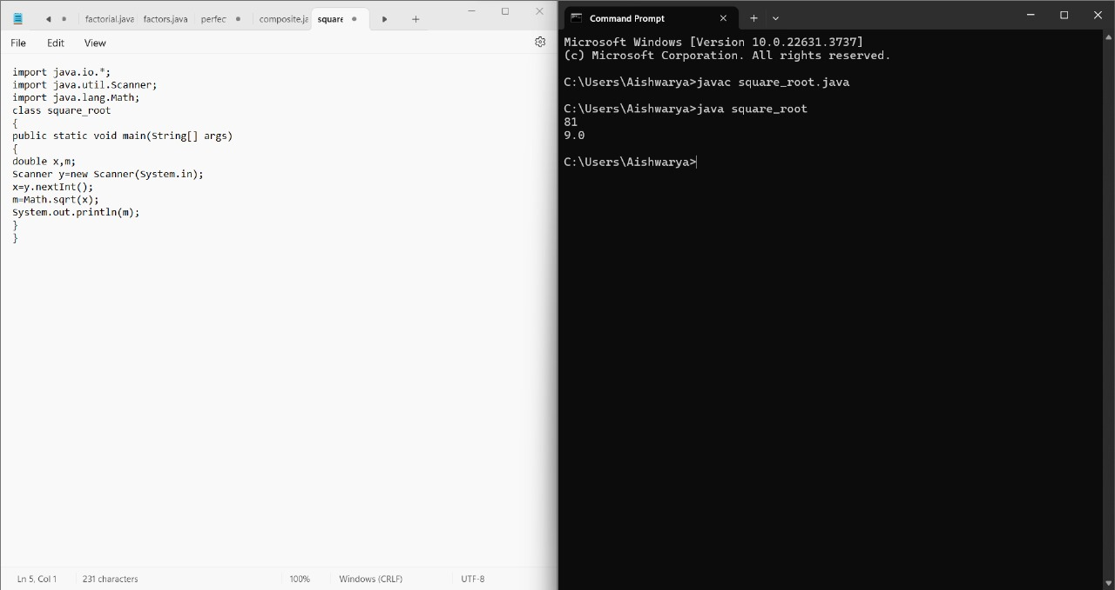

5. Write a java code for perfect number for 4 digits.

